2019

Yakima Fire Department’s Annual Report

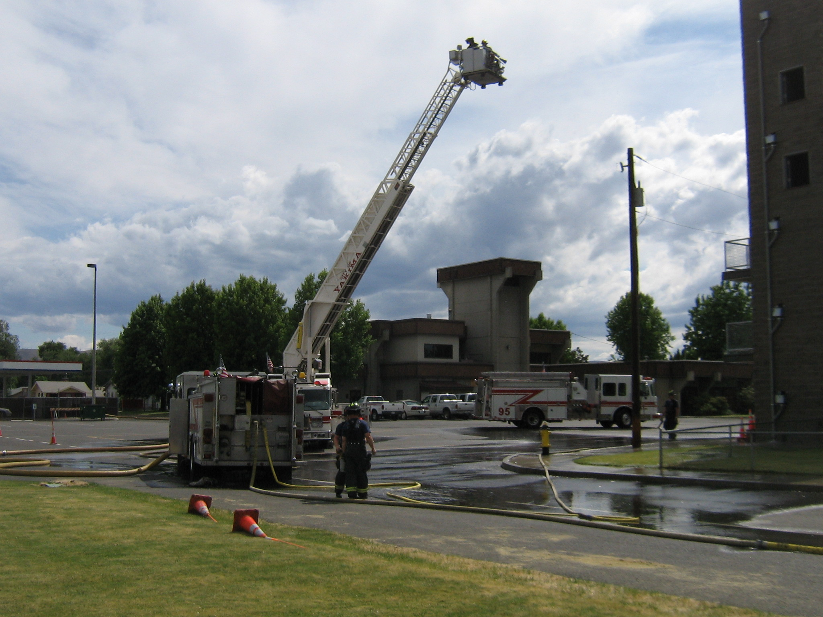

Contents

**Message from the Fire Chief 2**

**Fire Department Operations ……………………………………………………………………………………………………………………………….3**

**Fire Department Training Division……………………………………………………………………………………………………………………….6**

**Fire Apparatus and Fleet Maintenance Division…………………………………………………………………………………………………9**

**Fire Stations……….……………………………………………………………………………………………………………………………………………..12**

**Fire Investigations……………………………………………………………………………………………………………………………………………..14**

**Fire Peer Support Team……………………………………………………………………………………………………………………………………..15**

**Fire Preventin & Education Division……………………………………………………………………………………………………………..……16**

**SunComm………………………………………………………………………………………………………………………………………………………….18**

### Message from the Fire Chief

March 30, 2020

Honorable Mayor, Yakima City Council Members, and City Manager Bob Harrison,

The Yakima Fire Department (YFD) continued to experience numerous changes during the course of 2019. As your Fire Chief, I want you to know we are continuously monitoring and evaluating the ways in which we provide the essential services to the residents of Yakima, in an effort to be as effective and efficient as possible. The most valuable asset to our department is our members; the men and women who are our responders, our 911 communications team, and our support personnel, who together as a team responded to over ten thousand emergency incidents throughout 2019. As a department that is responsible for the mitigation of all risks and hazards, our members have countless hours invested in training. This training is required to maintain our operational readiness and also provides safety to our teams and the residents of our City. The purpose of this annual report is to highlight the activities of each of the divisions that make up our department and to acknowledge the achievements they made in 2019.

I would like to draw attention to the numerous challenges the fire department has had over the year. They include: the ability to meet the response times outlined by Council and providing fire prevention education to our residents, particularly our elementary school students. These interactions early on and continued throughout their early learning years help develop good fire safety habits. Another ongoing challenge YFD had to contend with throughout the year was the “Brown-Out” of ambulances by the private ambulance providers. These staffing issues create longer on scene times for YFD at medical emergency incidents. This year’s annual report implemented the SWOT (Strengths, Weakness, Opportunities and Threats) Analysis which allowed YFD, as an organization, to be holistically defined.

On behalf of the entire department, I want to thank you for your continued support. It is an honor and privilege to serve you as the Chief of the Yakima Fire Department.

Respectfully,

Aaron J. Markham, Fire Chief

Fire Department Operations

The Operations Division of the Fire Department is responsible for mitigating all fires (structural, wildland, and others), emergency medical incidents, hazardous materials incidents, technical rescue incidents and natural and man-made disasters. Because of the workload, this division is staffed with 93 personnel who are tasked with mitigating the emergency incidents. The men and women of this division have the upmost pride and dedication in serving the residents and businesses in the City of Yakima.

**Strengths and Opportunities:**

Dedication: The members of the Yakima Fire Department are unwavering in their ability to rise up and meet the challenges of mitigating any emergency they are summoned to. Through their training, determination and drive they are focused on providing the best customer service through efficient and effective emergency service delivery to the residents and businesses of our community.

Service Delivery: As the City expands and the population grows, we need to maintain an emphasis on the ability of the Yakima Fire Department to meet the needs of the residents and the business community. As our population increases as well as ages, it will become increasingly dependent on the fire department to meet its needs through community paramedicine, lift assists, increased fire suppression and various other calls for service. If service demands are not met, the community may lose faith in the Yakima Fire Department and City leadership.

Dollar Value Protected vs Dollar Value Lost: In order for the City to flourish, it has to have both property and monetary value. The Yakima Fire Department responded to 3,933 fire incidents in 2019, with a property and monetary value of $76,603,601. Through the efforts of the members of YFD, the residents and businesses that suffered from those fire loses sustained less than a 6% overall loss in value; which is well below the national fire average.

Mutual Aid Agreements: The City of Yakima and Yakima Fire Department have developed a strong network of cooperation with several area Fire Departments (Selah, Sunnyside, Toppenish, Grandview and Wapato) as well as Fire Districts in Yakima County, the U.S. Army’s Yakima Training Center Fire Department and Kittitas Valley Fire and Rescue.

**Threats and Weaknesses:**

Personal Protective Equipment (PPE): One of the most important items for fighting fires is the PPE issued to our firefighters in order to prevent them from being exposed fire, the byproducts of fire and other hazardous environments they encounter during the execution of their duties. The Washington State Administrative Code (WAC) 296-305-02002 specifically outlines the use, maintenance, and replacement of structural firefighting clothing because of how vital this equipment is to fire and rescue operations. Yakima Fire Department is currently at a cross road with its PPE; more than half of what is in use (55 sets) is nearing its end of life cycle of 10 years of age. A financial commitment is required to establish a lifecycle replacement for Yakima Fire Department’s PPE.

Aggregate Response Times: Meeting nationally established response times to the various types of emergency incidents is critical for saving lives and property. Meeting response times is accomplished by having a defined Standards of Cover Plan in place; ensuring that fire stations are properly placed throughout the City to meet current and future service demands. The City of Yakima does not have this action plan in place and as a result is delivering service based on a Standards of Cover Plan that was developed over 50 years ago.

Fire Suppression Aggregate Response Times:

Turnout Time – Yakima Fire Department has adopted a turnout time standard of 120 seconds for a fire suppression incident. The department should meet this standard 90% of the time.

2019 Average- 102 seconds

**Met standard- 66%**

Travel Time – Yakima Fire Department has adopted a travel time standard of 240 seconds for the arrival of the first engine company to a fire suppression incident. The department should meet this standard 90% of the time.

2019 Average- 252 seconds

**Met standard- 68%**

Full First Alarm Assignment – Yakima Fire Department has adopted a response time standard of 480 seconds for the arrival of the full complement of a first alarm response to a fire suppression incident. The department should meet this standard 90% of the time.

2019 Average- 510 seconds

**Met standard- 43%**

Emergency Medical Service (EMS) Aggregate Response Times:

Turnout Time – Yakima Fire Department has adopted a turnout time standard of 90 seconds for an EMS incident. The department should meet this standard 90% of the time.

2019 Average- 91 seconds

**Met standard- 56%**

Travel Time – Yakima Fire Department has adopted a travel time standard of 240 seconds for an EMS incident. The department should meet this standard 90% of the time.

2019 Average- 254 seconds

**Met standard- 64%**

Special Operations (Hazardous Materials and Technical Rescue) Aggregate Response Times:

Turnout Time – Yakima Fire Department has adopted a turnout time standard of 120 seconds for a technical rescue incident. The department should meet this standard 90% of the time.

2019 Average- 152 seconds

**Met standard- 60%**

Travel Time – Yakima Fire Department has adopted a travel time standard of 240 seconds for a special operations incident. The department should meet this standard 90% of the time.

2019 Average- 425 seconds

**Met standard- 49%**

Aircraft Rescue and Firefighting (ARFF) Aggregate Response Times:

Turnout Time – Yakima Fire Department has adopted a turnout time standard of 120 seconds for an ARFF incident. This standard should be met 90% of the time.

2019 Average- 33 seconds

**Met standard- 100%**

Travel Time – Yakima Fire Department has adopted a travel time standard of 240 seconds for an ARFF incident. The department should meet this standard 90% of the time.

2019 Average- 53 seconds

**Met standard- 100%**

Wildland Fire Suppression Aggregate Response Times:

Turnout Time – Yakima Fire Department has adopted a turnout time standard of 120 seconds for a wildland fire incident. The department should meet this standard 90% of the time.

2019 Average- 109 seconds

**Met standard- 64%**

Travel Time – Yakima Fire Department has adopted a travel time standard of 240 seconds for a wildland fire incident. The department should meet this standard 90% of the time.

2019 Average- 343 seconds

**Met standard- 24%**

**Fire Department Training Division**

The Yakima Fire Department Training Division is led by Training Captain Alex Langbell and Training Lieutenant Joe Burbank and is administered by Deputy Chief Patrick Reid.

The mission of the Yakima Fire Department Training Division is to provide department personnel industry standard training in order to deliver the community that they serve the most advanced and trained professional firefighters.

2019 created some challenges for Yakima Fire Department and their Training Division. This division implemented the SWOT (Strengths, Weakness, Opportunities and Threats) Analysis operation concept which allowed them to prioritize the training needs of the organization.

**Strengths and Opportunities:**

Active Shooter Program – Yakima Fire Department’s Training Division has been working in cooperation with the Yakima Police Department (YPD), the Union Gap Police Department (UGPD) and the Yakima County Sherriff’s Office (YSO) for the last two years to develop, train and implement an Active Shooter Program for our communities. The program included training law enforcement officers, deputies, firefighters and EMS providers not only in our City but throughout Yakima County. Prior to this accomplishment YFD, YPD, UGPD and YSO did not have a formal response plan that fostered interagency cooperation and coordination. This program was developed and implemented using limited resources and without additional funding. This is just one of the programs Yakima Fire Department has in place to ensure our City is holistically prepared to mitigate an emergency or event that may impact our residents.

Officer Development Program – The YFD Officer Development Program was established after Yakima Fire Department conducted a training needs assessment. The assessment identified YFD’s inability to develop/mentor current and future leaders of the organization. After two years of development, the Officer Development program was launched on January 1, 2020. The program’s educational curriculum was designed and written from scratch after researching how other fire departments throughout the country developed their officer programs. Throughout the entire history of Yakima Fire Department there has never been a formal training program that has developed firefighters into future leaders and taught them how to manage personnel. The YFD Officer Development Program, developed and implemented using the department’s limited resources, meets state and national standards for accreditation; this is a significant accomplishment for Yakima Fire Department. This program will ensure the officer’s in Yakima Fire Department have the knowledge, skills and abilities to lead the organization into the future.

Firefighter Probation Program – Yakima Fire Department’s probation program is designed to provide the basic skills, knowledge and abilities needed to be one of our firefighters. YFD’s firefighter probation program went through an extensive overhaul in 2019, which included extending the training academy to twelve weeks in length, revamping the training curriculum to meet State and National standards as well as setting new performance and monthly testing standards for our probationary firefighters that comply with Chapter 296-305 WAC. Another reason for overhauling the Firefighter Probation Program was to ensure that at the conclusion of the twelve month probationary period, the new firefighters would be able to acquire state and national accreditation.

Mandatory and ongoing training for all personnel – All YFD personnel, along with many firefighters throughout the region, are provided hundreds of hours of instruction by Yakima Fire Department’s Training Division each year on state required training and new industry leading training topics. Our department members logged over 7,500 hours of ongoing training total in 2019.

City Council: Enhance their understanding of the vital role that firefighter training plays in keeping the firefighters, the City and its residents safe. Provide Council awareness in the cycle of training, which is a continuous process that begins at the start of the firefighter’s career and continues throughout until their retirement.

**Threats and Weakness:**

Research: Continued research is being conducted by Underwriters Laboratories (UL) and National Institute of Standards and Technology (NIST) on fire behavior, which is very dynamitic. The results of this research is placing fire service in a constant state of transition because of having to train our firefighters on the new concepts that are being developed/adopted as a result of the fire behavior research. YFD funding restrictions limit our ability to access nationally recognized subject matter experts who provide training on the research that has been developed in areas of fire behavior; restricting our ability to enhance the knowledge and skills of our personnel and our ability to apply it to our operations.

Budget: The 2019 City Budget allocated thirty-four thousand dollars for Fire Department Training which was a reduction from the seventy-five thousand dollars that was allocated in previous budget cycles. This reduction in funding has directly impacted YFD’s ability to meet the challenges of training our personnel. We have been very limited in our ability to purchase/upgrade training curriculums, props, videos, books and supplies as well as to keep our Training Division Staff current on the new techniques being applied in fire service training.

Staffing: In recent years, YFD has lost staffing to include the Day Shift Commander position, which was responsible for Training Division Administration, Safety and Compliance with Washington State L&I, Probationary Firefighter Oversight and Emergency Medical Services. The loss of the Day Shift Commander position has shifted the responsibilities to both the Training Captain and Training Lieutenant. The Training Captain now fills the role of the Day Shift Commander; developing training curriculums, creating training films and delivering State of Washington mandated Emergency Medical Technician in-service training to all YFD personnel. The Training Lieutenant’s role has also expanded to include administering all probationary firefighter academies (90 day training academies and overseeing new firefighter probation) and delivering State of Washington mandated firefighting in-service training to all YFD personnel. The staffing shortage within the Training Division has made it challenging for YFD to stay in compliance with all of the Washington State and Federal regulations.

The Yakima Fire Department’s Training Facility: The YFD Training Facility was a state-of-the-art regional training facility used by many different agencies throughout the region and state. Thousands of firefighters and law enforcement personnel as well as other first responder agencies have used the facility throughout the 24 years of its existence. In late 2016, YFD started experiencing issues with the burn simulator function (burn room) of the training facility and at that time the cost to make repairs was fifty thousand dollars. The repairs were not identified in the 2016 or 2017 budget cycle but, continued problems with the fire training system existed. The need for repairs were identified again in 2018 and 2019 but due to very tight budget cycles again in those years, the repairs were not able to be proposed for either of those budget cycles. The manufacturer of the fire training simulator recommends that the system be overhauled and/or upgraded or replaced after 20 years, which is where we are today. The fire training prop has numerous components that are not functioning and need replacement and/or upgrading to make the training simulator operational.

The current estimated baseline cost to repair the fire training system, so that it is once again functional, is two hundred and fifty thousand dollars; these repairs will extend the life of the training facility another twenty years. Having a burn room that is no longer operable also creates a challenge for our department in regards to meeting annual live fire training requirements set by the WAC and Washington State Department of Labor & Industries. Our department has had to seek alternative methods to meet the standard and in most cases this has degraded our ability to maintain standardized training.

**Fire Apparatus and Fleet Maintenance Division**

The Yakima Fire Department’s Fleet Maintenance Division is led by Fire Mechanic II Mark Frey and Fire Mechanic I Paul Weeks and is administered by Deputy Chief Jeremy Rodriguez.

The mission of Yakima Fire Department’s Fleet Maintenance Division is to provide service, maintenance and testing of fire department heavy fire apparatus and staff vehicles that meets manufacturer and industry standards.

2019 created some challenges for the Yakima Fire Department and the Fleet Maintenance Division. This division implemented the SWOT (Strengths, Weakness, Opportunities and Threats) Analysis operational concept which allowed them to prioritize the apparatus needs of the organization.

One of the most significant components of Yakima Fire Department’s ability to protect our community is our fleet of Fire Apparatus (Fire Engines, Ladder Trucks and Heavy Rescue). The Yakima Fire Department currently staffs the following front-line apparatus: 5 engines, 1 ladder truck and 1 heavy rescue (cross staffed by an engine company). In addition to the front-line apparatus, YFD maintains 3 engines and 1 ladder truck in reserve for use by off-duty crews that are required to respond from home to assist with large fires/emergency incidents or for use when a front-line apparatus goes out of service due to a mechanical repair/preventive maintenance.

Fire apparatus are vital to YFD’s mission and its ability to meet the service demands of the community and our residents. In 2015, the Yakima City Council adopted a vehicle replacement plan for the Yakima Fire Department as a part of its Strategic Initiative. The Strategic Initiative outlines the service life for all fire apparatus; specifically outlining the life span for a fire engine, a ladder truck and the heavy rescue. Council outlined that a fire engine would serve 12 years in the capacity as front-line response apparatus and then for 5 years afterwards as a reserve apparatus. Once a fire engine reaches 17 years of age it would be replaced with a new fire engine and the old fire engine would be sold using a government surplus property process. A ladder truck would serve 15 years as a front-line response apparatus vehicle and 5 years as a reserve apparatus. The heavy rescue serves 15 years as a front-line response apparatus vehicle and 5 years as a reserve apparatus. Once the ladder truck and the heavy rescue reaches 20 years of age they would be replaced with new apparatus and the old apparatus would be sold using the process outlined above.

When Council adopted the vehicle replacement plan as a part of their Strategic Initiative, it was to ensure the Yakima Fire Department met compliance with Washington Administrative Codes (WAC) 296-305-04501, 04503, 04505, 04507, and the National Fire Protection Administration (N.F.P.A )1911 Standard for the Inspection, Maintenance, Testing and Retirement of In-Service Emergency Vehicles. Council understood the importance of meeting compliance with the Washington Administrative Codes and the National Fire Protection Administration Standards and demonstrated that they understood the integral role fire apparatus play in protecting the safety of the community, residents, and the firefighters with their vehicle replacement plan.

**Strengths and Opportunities:**

Fleet Maintenance: This division, because of their knowledge, skills and abilities is able to keep an aging fleet of heavy fire apparatus and staff vehicles functioning. They have overcome numerous issues and challenges this past year in maintaining our fire apparatus and support vehicle fleet. It is because of their resiliency that YFD’s fleet is running and meeting the mission/service demands of the community and residents. The Fire Mechanics are responsible for maintaining YFD’s fleet of apparatus and support vehicles, totaling approximately 47 vehicles. Additionally, they maintain components of Yakima’s five fire stations and Union Gap’s fire station, YFD’s breathing apparatus air compressors, station vehicle exhaust systems and small engine equipment (chain saws, positive pressure fans and much more). 2019 was a very busy year for the Fire Maintenance Division. YFD Fire Mechanics oversaw and/or completed over $184,000 worth fire apparatus, vehicle and fire station repairs. The apparatus repairs ranged from major fire pump overhauls, engine turbo replacements and aerial safety mechanisms to standard maintenance and annually mandated apparatus testing while the station repairs included repairs to YFD’s breathing air compressors, vehicle exhaust systems, and fire station generators.

Apparatus Specifications:The Yakima Fire Department formed a standing process action team (PAT) comprised of company officers, firefighters and a Fire Mechanic to develop new fire engine specifications that will meet the current and future needs of the Yakima Fire Department. The team meets quarterly to review and update the fire engine specifications so that when YFD is authorized to purchase new apparatus we can immediately move forward with the procurement process.

**Threats and Weakness:**

The Mission Capability: The Yakima Fire Department is fast approaching critical failure because fire apparatus replacement has not been a priority for the previous budget policy issues. The urgent need for fire apparatus long range funding has not been thoroughly addressed and has postponed addressing fire apparatus replacement with City Council. Funding has not been allocated in the Yakima Fire Department’s budget since the 2017 approved budget. Three fire engines are in immediate need of replacement because of life cycle replacement and because they have become a financial burden to maintain. Additionally, the heavy rescue apparatus (purchased used from the Coca-Cola Company) is more than 30 years old and has become a financial and maintenance liability. The heavy rescue is as vital to the YFD mission/services delivery as are the fire engines.

Ladder Truck: Truck 91 (the Ladder Truck with a second driver in the rear) is currently 10 years old. By most standards it should still have several years of service left in it, but we have been experiencing a near continuous series of mechanical issues with it. Each year, for the past three years, Truck 91 has been sent back to the manufacturer in Oregon for substantial repairs; repairs above and beyond what our Fire Mechanics were capable of doing. Overall, TK91 is spending nearly 5 five months, or more, out of service for repairs each calendar year. Considering the ongoing cost of maintaining that apparatus and its continuously being placed out of service, it is in the best interest of the City to replace this apparatus sooner than later.

The table below outlines the age, mileage and engine hours of the Yakima Fire Department Heavy Fire Apparatus (the Mileage Equivalent calculation is based on the number of hours recorded on that apparatus’s engine):

Apparatus Year Age in 2020 Mileage Engine Hours Incident Volume purchased

Designator

E-91/4517 2010 10 201,000 6700 15405

**E-92/4516 2008 12 285,000 9500 10607**

**E-292/4515 2005 15 300,000 10,000 20000+**

E-93/4519 2013 7 177,000 5900 12075

**E-293/4514 2003 17 330,000 11,000 26000+**

E-94/4523 2016 4 45,000 1500 4452

E-95/4518 2010 10 177,000 5900 12580

**E-295/4513 2000 20 270,000 9000 20000+**

**TK91/5505 2010 10 150,000 5000 18064**

Age and Mechanical Condition of the Heavy Fire Apparatus Fleet: Because of the emergency call volume and the history of the City of Yakima buying baseline apparatus, YFD’s apparatus are unable to continue to mechanically sustain the increasing workload. YFD is at critical mass with the age and the mounting and continued maintenance costs of its staff vehicles and heavy fire apparatus. In a proactive posture, the Yakima Fire Department has developed new specifications for our heavy fire apparatus fleet that ensure that any future apparatus purchases will be mechanically sound to meet the current and the future service demands thus reducing the down time for maintenance and ensuring that our heavy fire apparatus fleet will meet the 17-year life cycle expectancy that Council implemented in 2015.

Fire Stations

The City of Yakima Fire Department currently operates out of five fire stations located within Yakima city limits and one located in the City of Union Gap. The Yakima Fire Department’s service delivery area within the City of Yakima is 27.7 square miles, the City of Union Gap is 5 square miles, Yakima County Fire District #10 is 1 square mile and Yakima County Fire District #11 is 2.5 square miles.

The Yakima City Council has adopted a series of performance measures for the Yakima Fire Department. The purpose of adopting these measures is to meet the compliance requirements outlined by the Revised Codes of Washington (RCW). The specific RCW’s City Council adopted are 52.33, 53.56, and 35.103. A benchmark outlined in the performance measures set by Council for the Yakima Fire Department require that the first arriving YFD fire apparatus must by on the scene of the emergency medical incident within 5 ½ minutes and on the scene of a fire incident within 6 minutes after being notified of the emergency (time of dispatch to arrival on scene).

**Strengths and Opportunities:**

Strengths: Yakima Fire Department continues to function effectively out of its aging facilities that present numerous challenges for the organization. YFD has longer response times so it often dispatches numerous fire apparatus to meet the response criteria.

Standard of Coverage: Development of a standard of coverage that outlines where future fire stations will be located is needed. Taking this proactive approach would ensure that fire stations are positioned to meet compliance with RCW 53.56; giving Yakima Fire Department the ability to meet the six (6) minute aggregate response time for the arrival of the first arriving engine company at a fire suppression incident and the eight (8) minute aggregate response time for the deployment of a full first alarm assignment at a fire suppression incident. It will also ensure that the Yakima Fire Department meets the 5 ½ minute aggregate response time for the arrival of a unit with first responder or higher-level capability at an emergency medical incident.

The standard of coverage document will establish a strategic resource deployment plan for Yakima City Council and the City Manager on the response capabilities of the Yakima Fire Department. This will assist in outlining the need for future capital investments to improve fire and emergency medical delivery to all areas of the city.

**Weakness and Threats:**

Weakness: Population growth, city annexations and business/residential development have created a fire and EMS service delivery gap within the City of Yakima. The service delivery gap exists because the Yakima Fire Department does not have a uniformed standard of coverage throughout the City of Yakima. The service delivery gap is evident with the fire department not being able to meet the City Council’s response standard that mandated the Yakima Fire Department to meet response times of 5 ½ minutes for emergency medical incidents and 6 minutes for fires and rescue incidents (from time of dispatch to arrival on scene). As a result of the significant growth and annexations taking place in southwest Yakima (Council District #7), the closest Yakima Fire Station is station 92 which is located at 7707 Tieton Drive. Station/Engine 92 has response times of 12-18 minutes into the Apple Tree section of the City. More often than not, Engine 92 operates alone for longer periods of time at multi-company emergency incidents due to the extended response times of fire companies coming from the eastside of the City. Because of not having a uniformed standard of coverage, the residents in the southwest portion of Yakima are currently being severely underserved in relation to the residents who live east of 40th Avenue (fire station 91, and 95 are located east of 16 Avenue, fire station 94 is located on S. 24th avenue and fire station 93 is on N. 40th Avenue and Englewood).

Weakness: Beyond the challenge of the number and location of our fire stations, YFD’s station facilities also face notable challenges. Fire Station 91 and Station 95 were built in 1971-72 (49 years old); their concrete construction hides a number of growing issues. Current problems associated with these two stations include the heating and air conditioning units which are well beyond their life expectancy and are in need of replacement. The HVAC duct work, plumbing, electrical systems, lighting and security systems are all in need of repair and/or replacement. Temporary repairs have been made and have left us with systems that are not energy or cost inefficient to operate. Fire Station 95 still maintains dormitory style sleeping quarters. The department is comprised of a workforce of both genders, dormitory style quarters represents a significant sub-standard arrangement.

Fire Station 92 is our western most fire station, located at 7707 Tieton Drive. The City of Yakima inherited this station from Fire District 12, West Valley Fire Department, as a part of a large west side annexation that occurred in 2005. This fire station was originally designed to operate as a volunteer fire station which was never intended to be occupied by a full-time career staff who occupy the facility 24-hours a day year-round. In 2008, the station underwent a limited remodel that updated the living quarters which included the addition of dorm rooms, a kitchen, and office work space. This remodel did not improve the electrical system, lighting or heating and air conditioning systems on the old/original portion of the building. The concrete parking areas for the station have also begun to deteriorate and are now in desperately needing to be replaced.

Fire Station 93 was built in 1997 and is located at 507 N 40th Ave. This is the only fire station Yakima that was built after 1972. Overall this station remains in good condition, but it too is beginning to experience issues from age and usage. In 2019 both heater units for the building had a catastrophic failure and had to be replaced. The air conditioning units, station compressor, light fixtures and building siding are all currently in need of repair or replacement.

Fire Station 94 is located at the Yakima Airport. This station serves the airport and significant portions of central Yakima, Union gap and Yakima County Fire District #11. Fire Station 94 was built in the early 1960’s and has served the Yakima Fire Department for decades. Station 94 received an addition in the mid 2000’s to improve the living and working condition. Despite that, the building continues to have water and snow leaks in the roof which has potentially caused damage to the structural components of the roof, mold/mildew issues and the leaks have damaged electronic equipment inside of the station.

Fire Investigations

The Revised Code of Washington (RCW) 43.44.050 places the responsibility with the Fire Chief to determine the cause, origin and circumstances for all fires that occur within the City of Yakima. In addition to determining the cause of fires within the City limits, the Yakima Fire Department also has entered into Interlocal Agreements to investigate fires occurring within the City of Union Gap, Yakima County Fire District #10, Yakima County Fire District #11 and Yakima County Fire District #12.

The table below outlines the number of fires that the Yakima Fire Department has investigated in a four-year period and the number of Intentional or Under Investigation fires:

Year Total # Fires # of fires Intentional or Under # of Houses Investigated Investigation businesses burned

**2019 500 408 58% 215**

2018 578 478 55% 256

2017 441 372 52% 204

2016 452 372 52% 199

In 2019, the City of Yakima had one person pass away in a house fire. There were 500 fires (of various types) during the year with more than $4,800,000 worth of property destroyed from fire. There was only one arson arrest, which was accomplished in early 2019. Despite that accomplishment, the long-term trend clearly indicates an increasing fire problem. Yakima’s growing numbers of people experiencing homelessness, poor housing conditions, continuing crime problems and our limited inspection capability are all contributing this growing problem. This fire problem is currently centered around central and eastern portions of Yakima.

Despite significant limitations, Yakima Fire Department is attempting to address these challenges. YFD currently has twelve cross trained firefighter/investigators. These individuals have taken numerous courses to learn the process of fire investigation. Five of the Investigation Team members have become trained Fire Investigation Technicians through the International Association of Arson Investigators (IAAI-FIT). They are responsible for performing all of the duties of a firefighter with their fire investigator duties relegated to secondary status. They consistently struggle to follow up on open and suspicious fires and to link the commonalities of various fires. Yakima Fire Department currently lacks a full-time dedicated Fire Investigator; the last year that YFD had a dedicated Fire Investigator was 2010. In that year, YFD made nine arrests for illegal burning and arson as well as completed the trial for the “May Day Mob” with multiple convictions for arson. Since that time, YFD has not had the capability to handle this growing fire problem.

**Fire Peer Support Team**

**(New Program - Zero Cost)**

The stresses faced by fire service members throughout the course of their careers – multiple casualty events, fire fatalities, death, violence, injury to children, sleep deprivation, stress and the inherent dangers of firefighting – can have both acute and cumulative impacts on the mental health and well-being of our firefighters. Unfortunately, our Yakima Firefighters face all of these challenges while performing their duties. Over the years there have been many different programs designed to help firefighters cope with these difficult problems. Recent evidence and experience from events like the 9/11 attacks have clearly shown the effectiveness of Peer Support Programs. Peer Support Programs are an effective method for providing support and building resilience (recovery) for fire fighters. Statistics show that for every dollar spent on firefighter wellness, four dollars are saved on behavioral and physical health treatments. Over the last 30 years the Yakima Fire Department has had multiple members retire on “stress” or “PTSD” related disabilities. In 2019, 58 firefighters in the United States were killed in the line of duty and an alarming 113 died by suicide. This is not a new problem, but it is only now becoming recognized within the fire service. The Yakima Fire Department and the Yakima Firefighters Association, IAFF Local 469 have come together in a joint venture to try to prevent this terrible possibility and to improve the lives and health of our firefighters.

In December 2019, 14 Yakima firefighters participated in a 16-hour class to become certified Peer Supporters. *This important class was sponsored and paid for by the Yakima Firefighters Association, IAFF Local 469.* This class is designed to teach them how to help those that view themselves as “helpers”. Students from eight other Fire Departments attended this two-day training at the Yakima Fire Department Training Center. After completing the IAFF training, members became Certified IAFF Trained Peer Supporters and have the necessary knowledge and skills to provide support to their peers, to educate brothers and sisters about behavioral health (e.g.: PTSD and resilience) and to serve as a bridge to behavioral health programs and community resources.

This newly created Peer Support Team began assisting members of the Yakima Fire Department and SunComm in early 2020. This peer-based program promotes wellness and access to a wide variety of assistance programs in behavioral health, marriage and relationships, substance abuse, loss, grief, PTSD and others. Yakima Fire Department and Yakima Firefighters Association, Local 469 recognize the value of keeping our firefighters physically and mentally fit for duty while living healthy and fulfilling lives. This program is an exciting example of how a labor and management partnership can achieve a positive working relationship that demonstrates the importance and value of caring for our firefighters, dispatchers and support staff as well as other first responders.

Fire Prevention & Education Division

(Eliminated by City Council January 1, 2019)

Fire prevention is a critical mission for the Fire Department because of how it reduces fires, injuries and death. Fire Prevention is a community risk reduction program that focuses on the most vulnerable groups within a community, which is the elementary children and the senior population. Fire Prevention is a factor that Washington Surveying & Rating Bureau looks at when assessing the fire insurance rating of a community. In 2017, the City’s insurance rating was evaluated and determined to be a “3” which resulted in significant lower insurance premiums for our residents and our business community. As a result of a 2019 budget decision, the city council did not fund the fire department’s Fire Prevention Captain position. As a result of the Public Education Captain position being unfunded, a void was created in the fire department’s ability to meet community risk reduction responsibilities. In addition to not being able to conduct fire safety education as it did in previous years, the fire department has not been able to conduct its juvenile fire setter program to its fullest potential. Prior to 2019, the fire department counseled 30 or more students annually.

**Strengths and** **Opportunities:**

Reinstatement: The City Council and the Fire Department have the opportunity to reinstate the Fire Prevention Captain position. This would restore the robust fire prevention and juvenile fire setter program that was previously in place and provide these essential services to the residents and businesses of our community. The fire prevention and juvenile fire setter program will reduce the high property and dollar loss the City is currently experiencing by decreasing the number of accidentally and intentionally set fires.

**Weakness and** **Threats:**

Fire Prevention Education: Yakima Fire Department has struggled to maintain a fragment of its fire prevention and education program through the use of the fire code inspectors, fire company officers and firefighters. Experience has taught us that the best way to fight a fire is to prevent it in the first place. The Yakima Fire Department remains steadfast in its commitment to preventing fires and teaching our community how to be fire safe. We are continuing to search for ways to fill the education and prevention gap until such time that we are able to reinstate a funded and staffed Fire Prevention and Education Division for our community.

Increased Risk and Danger: The Fire Prevention & Education Division’s primary responsibility was to educate residents in our community about the risks from fire, home and business hazards and injury prevention. These efforts are generally categorized as Community Risk Reduction. Community Risk Reduction programs are paramount in preventing tragedies and minimizing life and property loss resulting from fire. These programs also greatly assist the most vulnerable populations like our youth and elderly by helping to connect them to essential services like in home care, assisted living facilities and youth/elder care organizations.

Fire Prevention and Education took the lead on community contact and education. Services like smoke detector installations, school exit drills, business fire prevention education, fire extinguisher training and elementary school fire safety education are a small representation of the responsibilities of that division. Unfortunately, the elimination of the Public Education Captain position essentially eliminated YFD’s ability to provide this crucial service to our community. Community contact and education with the Yakima Fire Department has been reduced to moments during emergency 911 calls. This vital division within the Yakima Fire Department no longer has any personnel in it and these vital tasks for our community’s safety are no longer being addressed. If the City and the fire department continue to neglect the fire prevention and juvenile fire setter programs, our fire insurance rating could increase which in turn will increase the cost of fire insurance premiums for our residents and business owners. This in turn may have an adverse effect on future building construction and renovations to housing and commercial properties.

The statistics below are a small selection of the activities that the Yakima Fire Department Fire Prevention and Education Division carried out over the last four years:

**Fire Prevention Programs**

Year Smoke detector Installations School Exit drills 2nd Graders Educated

2016 230 20 over 2400

2017 170 20 over 2200

2018 258 20 over 6700

**2019 50 0 0**

Year Fire Extinguisher Adults Trained Adults Receiving Training Classes (business) in Extinguishers Fire Education

2016 9 110 3500+

2017 18 161 3000+

2018 30+ 1300+ 3800+

**2019 0 0 0**

.

**SunComm**

**Call Statistics-**

Total 911 Calls: 147,043

Admin Lines: 140,981

Text-2-911: 192*

*SunComm accepted thousands of texts throughout 2019, however only texts that resulted in a call for service were counted toward text totals.

**Average 911 Call Answer Times by Month-**

The National Emergency Number Association (NENA) call answering standard/model recommendation is that 90% of all 9-1-1 calls are answered during peak hours within 10 seconds. SunComm did an exceptional job exceeding those standards during all hours, not just during times of peak call volume, despite consistent under-staffing throughout 2019.

January: 99.66% in 4.135 Seconds July: 99.98% in 4.498 Seconds

February: 99.58% in 4.098 Seconds August: 99.99% in 4.430 Seconds

March: 99.75% in 4.276 Seconds September: 99.95% in 4.447 Seconds

April: 99.93% in 4.213 Seconds October: 99.99% in 4.286 Seconds

May: 99.87% in 4.199 Seconds November: 99.99% in 4.445 Seconds

June: 99.93% in 4.176 Seconds December: 99.98% in 4.442 Seconds

**Response Statistics-**

In 2019, SunComm dispatched the following number of incidents for the following agencies:

Yakima Fire: 10,619

Yakima Police:

Dispatched Incidents- 88,160

Traffic Stops- 22,148

Yakima County Fire Districts: 3,492

Union Gap Police:

Dispatched Incidents- 7,719

Traffic Stops- 2,015

**Warrants-**

SunComm enters all warrants for the Yakima Police Department. In 2019, we entered 3,259 warrants into Spillman, WACIC and NCIC making those warrants available to be served by law enforcement agencies nationwide within 72 hours of their issuance according to Washington State ACCESS standards. The average time calculated to process a warrant from intake to final audit is approximately 20 minutes. This equates to just over 1,806 hours of SunComm employees being dedicated to this task.

Additionally, SunComm handled 523 warrant recalls from both Superior and Municipal court this year. On average it takes approximately 5 minutes to complete one recall, equating to an additional 43.5 hours of work dedicated to this task.

Collectively, SunComm has committed approximately 1849.5 hours to warrant tasks in 2019 which equates to nearly one full time position, as calculated for the standard annual hourly calculation of 2,080 hours for one full time position.

**Public Disclosure Requests-**

SunComm’s Administrative Assistant processed approximately 3,000 public disclosure requests during 2019. These requests are for 9-1-1, radio audio recordings as well as CAD incidents and are being requested by user agencies, the public, investigators and prosecutors.

**Personnel Action-**

SunComm has 36 total personnel positions: three administrative positions (one Manager, one Assistant Manager and one Administrative Assistant), six supervisor positions (five floor supervisors and one training supervisor), 13 dispatchers and 14 call-takers. At the close of 2019, all administrative positions were filled, all supervisor positions were filled, nine of the thirteen dispatch positions were filled and eleven of the fourteen 9-1-1 call-taker positions were filled (two of which were still in training and on probation).

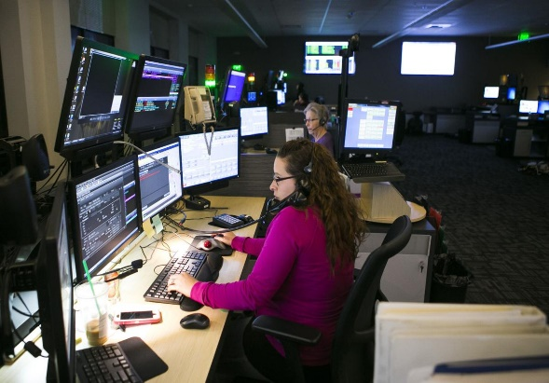Throughout 2019, SunComm had five members resign from their positions. One was a probationary Dispatcher, one was a returning Dispatcher who had vacated their position with SunComm for less than a year, two were probationary Call-takers and one was a Call-taker with eight years tenure. These resignations equate to an overall turnover rate of nearly 14%.

Throughout the majority of the year, SunComm was operating at a critically under-staffed level; 9/13 Dispatchers and 10/14 Call-takers on average. This resulted in excessive overtime expenditures, burnout of remaining employees and an increased sick leave usage. While it placed a huge burden and a demanding workload on those who maintained their positions serving the community, SunComm maintained their commitment to customer service and responder safety.

In 2019, the City of Yakima Human Resources Department saw 75 applicants for the open 9-1-1 Call-taker positions and 20 applicants for the open Dispatcher positions. Of these applicants, one Dispatcher was promoted from 9-1-1 Call-taker and four 9-1-1 Call-takers were hired. The overall hiring to applicant rate is about 5%.

The inability to recruit, hire and retain qualified applicants has been crippling to our organization. It’s required the Training Coordinator to spend nearly 50% of their time filling in as a Dispatcher or 9-1-1 Call-taker vs. focusing on SunComm’s training needs. SunComm’s Assistant Manager has been required to fulfill 9-1-1 Call-taker and Dispatcher vacancies as well resulting in an inability to focus on the requirements of her position, the service to user agencies and current employee needs. Overall understaffing has been acutely felt across the entire staff at SunComm; it is our greatest weakness and a terrible let-down to our dedicated team members.

**Training-**

Memo from the Training Supervisor (Brynn Sides):

Training in 2019, for new hires, had its ups and downs.  SunComm saw one Dispatcher that had been hired in late 2018, resign early in 2019; this resignation was prior to them completing the training process. Additionally in 2019, we promoted one Dispatcher from within. The Dispatcher that promoted has remained on staff and is continuing through the training process. Between trainees we restructured the Dispatch Training Program to begin with the fire discipline. We felt that this would help employees new to the radio experience learn by utilizing the structure that the fire department adheres to, while being able to gain exposure to the activity of the police side. This has been successful thus far, but we will not know fully until May of 2020 when the first trainee completes training in the police discipline.

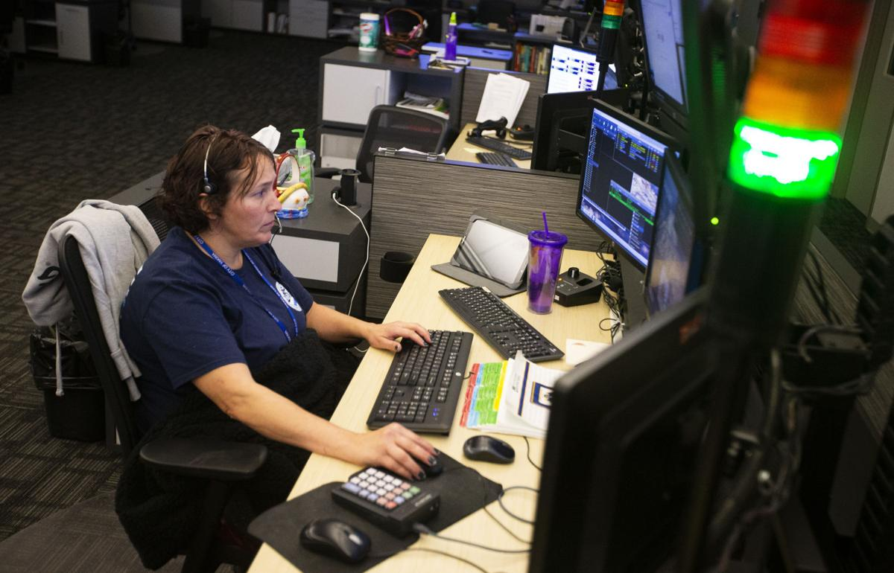

SunComm hired four Call-takers in 2019; one resigned prior to completing the training process and one resigned after completing the training process (both due to stress-related issues). Two are still in the training process; a mentoring program has been adopted in an effort to curb some of the stress-related issues experienced with this job. We are optimistic for both trainees as they are on track with their training timelines for release from the training program which is scheduled at the end of March 2020.

Hiring has been a struggle as it’s been difficult to get qualified candidates. We continue to work with the human resources department to bring in strong candidates and speed up the hiring process.

Staff training has been lacking, something we hope to improve upon next year.  Due to our staffing levels, I have been covering the Communications Floor as a Dispatcher or Call-taker frequently. When I fill in on the floor, it takes me away from my Training Supervisor duties, including developing staff training.  We have been working diligently to update and revamp our policies, as this would clear up many of the procedural issues we see, however it’s difficult to get these completed when covering radio or phones.

SunComm’s Quality Assurance (QA) Reviews that we have been receiving from a third-party company have helped staff to understand and better comply with industry standards as well as SunComm specific policy and procedure. In addition, we have found benefit in identifying employee-specific training needs which have resulted in improved employee QA scoring.  We have several trainings for staff planned out for 2020 and are enlisting in aid from the training team to help in developing staff training. This will ensure that our Dispatchers and Call-takers are invested in SunComm and are performing at their best.

**Public Education-**

Memo from the Public Education Coordinator Cameron Haubrich:

For the year of 2019, the 911 Public Education team and I made every attempt to exhaust as many avenues of contact with our community as possible. As our group expands in both resources and members, we are able to spend more time reaching out to our citizens for 911 safety tips as well as emergency services and available resources. We bridge the gaps of communication and correct many misconceptions and misunderstandings about the 911 and dispatching systems. Continual outreach has proven to be effective in both improving safety for our citizens and in creating a positive rapport with our community.

We made every attempt to fulfill each and every request for attendance at specific events hosted by user and neighboring agencies. As our program matures, we have grown in both resources and manpower allowing us to attend multiple events simultaneously. We did not have to turn down any requests for community involvement in 2019.

SunComm attended National Night Outs (NNO) for the City of Yakima as well as City of Sunnyside, Grandview and Selah (photos attached). At these events myself, Call-Takers Jenyne Wells and Barb Cruz, Dispatcher Albert Miranda and Supervisor Brynn Sides handed out informative flyers, educational color sheets for kids, answered many questions and socialized with the communities. We displayed the prize wheel where children could spin the wheel and answer the 911 specific question listed on the wheel and win a prize! We also introduced our interactive iPad, where children can practice calling 911, work in memorizing their phone number and address and other 911 safety practices. Every year our team attempts to diversify our handout material. The NNO events accounted for over 3500 positive contacts.

SunComm also set up a booth at the Yakima Trunk or Treat event. For the second year in a row call taker Belen Lopez and her husband, donned in costume, handed out candy and educational color sheets to attending children alongside other public safety agencies from around the county. This event alone accounted for over 1000 positive contacts.

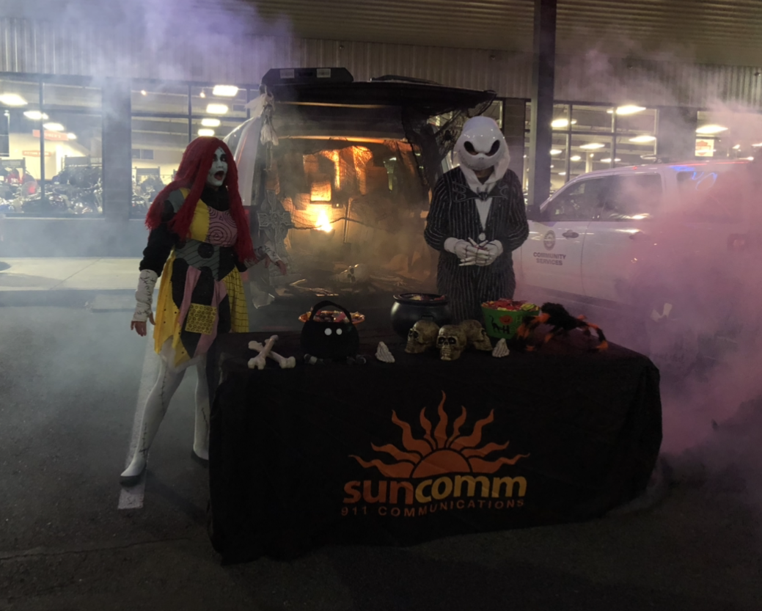

In addition to these public events, I had the opportunity on multiple occasions to speak to the Criminal Justice class at Yakima Valley College, the Fire Science Class at YV-Tech, Heritage University’s criminal justice course participants as well as the Yakima Police Citizen Academy. I use these opportunities to both educate the students of our systems and workplace and as a potential recruiting tool for prospective employees. These classes have generated interest in many students and have led to sit-ins and applications.

SunComm also hosted multiple tours to various community groups from across the valley. These tours consisted of a brief presentation of the 911 system and how it operates. This is typically followed by many questions and a lot of “myth busting”. The groups are then given a tour of the facility and the dispatch floor. We had many return groups in 2019 from years prior.

SunComm’s Public Education group continued our partnership with the Yakima Police Explorer Post. With this program, the YPD Explorers are paired with a SunComm employee and sit-in a minimum of four (4) hours each month. This allows the Explorer to experience both sides of the radio. We have found this to create an appreciation for Dispatch and 9-1-1 services while the Explorer is out on the road with an officer as well as an understanding of the cooperation between responders and 911 and how important this is for the safety of our community. To date, this program has led to multiple applications and one hire.

As our Program Coordinator, I was able to attend various trainings throughout 2019, including the National Public Educator Forum, hosted in Virginia Beach, Virginia. This was a 4-day conference where speakers from all over the country came and shared their expertise. This was also a great opportunity to network with agencies from all over the nation to bring back successes to try at home. I also attended the Washington APCO-NENA chapter Summer Forum hosted in Spokane. I actively participated in various trainings as well as assisted in a training involving cooperation between dispatch centers and user agencies.

In 2019, I was voted in by the Washington APCO-NENA Advisory Committee board unanimously as the Vice Chair for the Public Education Sub–Committee. With this role I will take direct involvement in the organization and implementation of Pub Ed curriculum statewide, organize bi-monthly meetings, annual forums/conferences and oversee various task forces. These task forces are in charge of updating the states Social Media pages, updating policies, contract deliverables and more. I will also sit on the State Advisory Committee as a liaison and representative for the sub-committee.

As we look forward to 2020 we will continue to grow each program to better suit the needs of our community and make every attempt to educate our residents for a safer Yakima.

**Tactical Dispatch-**

Memo from Team Leader: Brynn Sides:

In 2019, the tactical dispatch team continued to support the Yakima SWAT team and Yakima Fire on their high priority incidents. The team responded to seven incidents, including two second-alarm structure fires, a second-alarm brush fire and four SWAT incidents. We 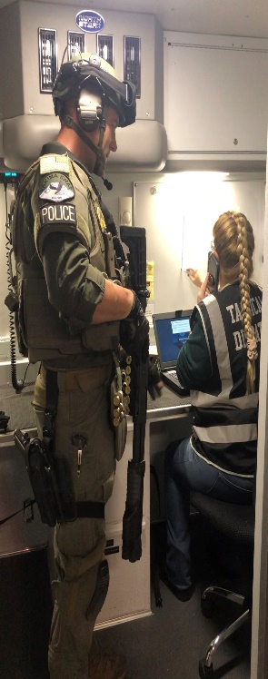participated in 25 hours of training that consisted of SWAT scenarios and acting as a crisis negotiator liaison to the tactical commander. Additionally, the team leaders attended Incident Command System (ICS) Classes 300 and 400, receiving their certification in both.

The team meets quarterly with Yakima Fire’s Shift Commander Jennifer Norton to discuss our needs, the needs of our responders and training on specialized forms necessary to maintain Incident Command.  We have been very successful in supporting our responders by using our specialized training to alleviate some of the duties that fall on the shoulders of the command staff.  Some of these duties include requesting mutual aid, making notifications, keeping a thorough log of activities and movement of responders, acting as a liaison between teams, benchmarking activities, fulfilling command requests and more. In 2020, we hope to expand our responses to assist in mass casualty incidents and make relationships with our responders from the county agencies where we can be of benefit to them in large incidents.

**CISM-**

Memo from CISM Team Leader Kristi Castillo:

The SunComm CISM team includes Angela Brown, Cheryl Miller, Kristi Castillo and Albert Miranda. During the 2019 year we were able to add new member Albert, who was sent to a 1st responder’s conference for his initial training.

Team members made 205 one-on-one contacts during the year; providing referrals, mental health days off and anything else needed by our staff. Yakima Police Department’s CISM team held three diffusions and included the SunComm staff in all of them; this was of great benefit to our staff and our team. The Yakima Fire department’s CISM team has also reached out to SunComm’s team and the two teams will be working together at times.

The CISM team was not able to attend any of the trainings that we requested, aside from Albert’s initial training. This was primarily due to a lack in staffing on the floor to cover CISM members being away at training. We have contacted the Yakima Police team and are hoping to be able to train with them at times. One of our goals for the upcoming year is to bring more trainings to our center for our staff and our families.

The mental and overall health of our staff is of the upmost importance to our team and we are going to focus on trying to train and educate our team members as much as possible to benefit our coworkers.

**TERT-**

SunComm maintained their partnership on the Washington State Telecommunicator’s Emergency Response Team, otherwise known as TERT through 2019. This team deploys to other Communications centers in the event of large-scale emergencies, allowing the employees at those communications centers the opportunity to focus on their families, homes and personal matters while our dispatchers work the imminent threat of the event.

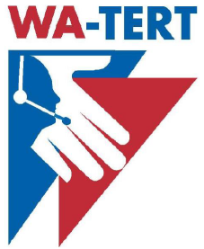

While our team did not deploy on or require assistance from TERT on any incidents in 2019, they maintained their certifications, held their annual planning meetings and were prepared throughout 2019 to aid in the event of any disasters. Mutually, if SunComm were to have faced a large-scale disaster in our area other TERT teams would deploy to and provide the same service to us, allowing our teams the same professional courtesy, if necessary, in the event of a large-scale emergency in our area.